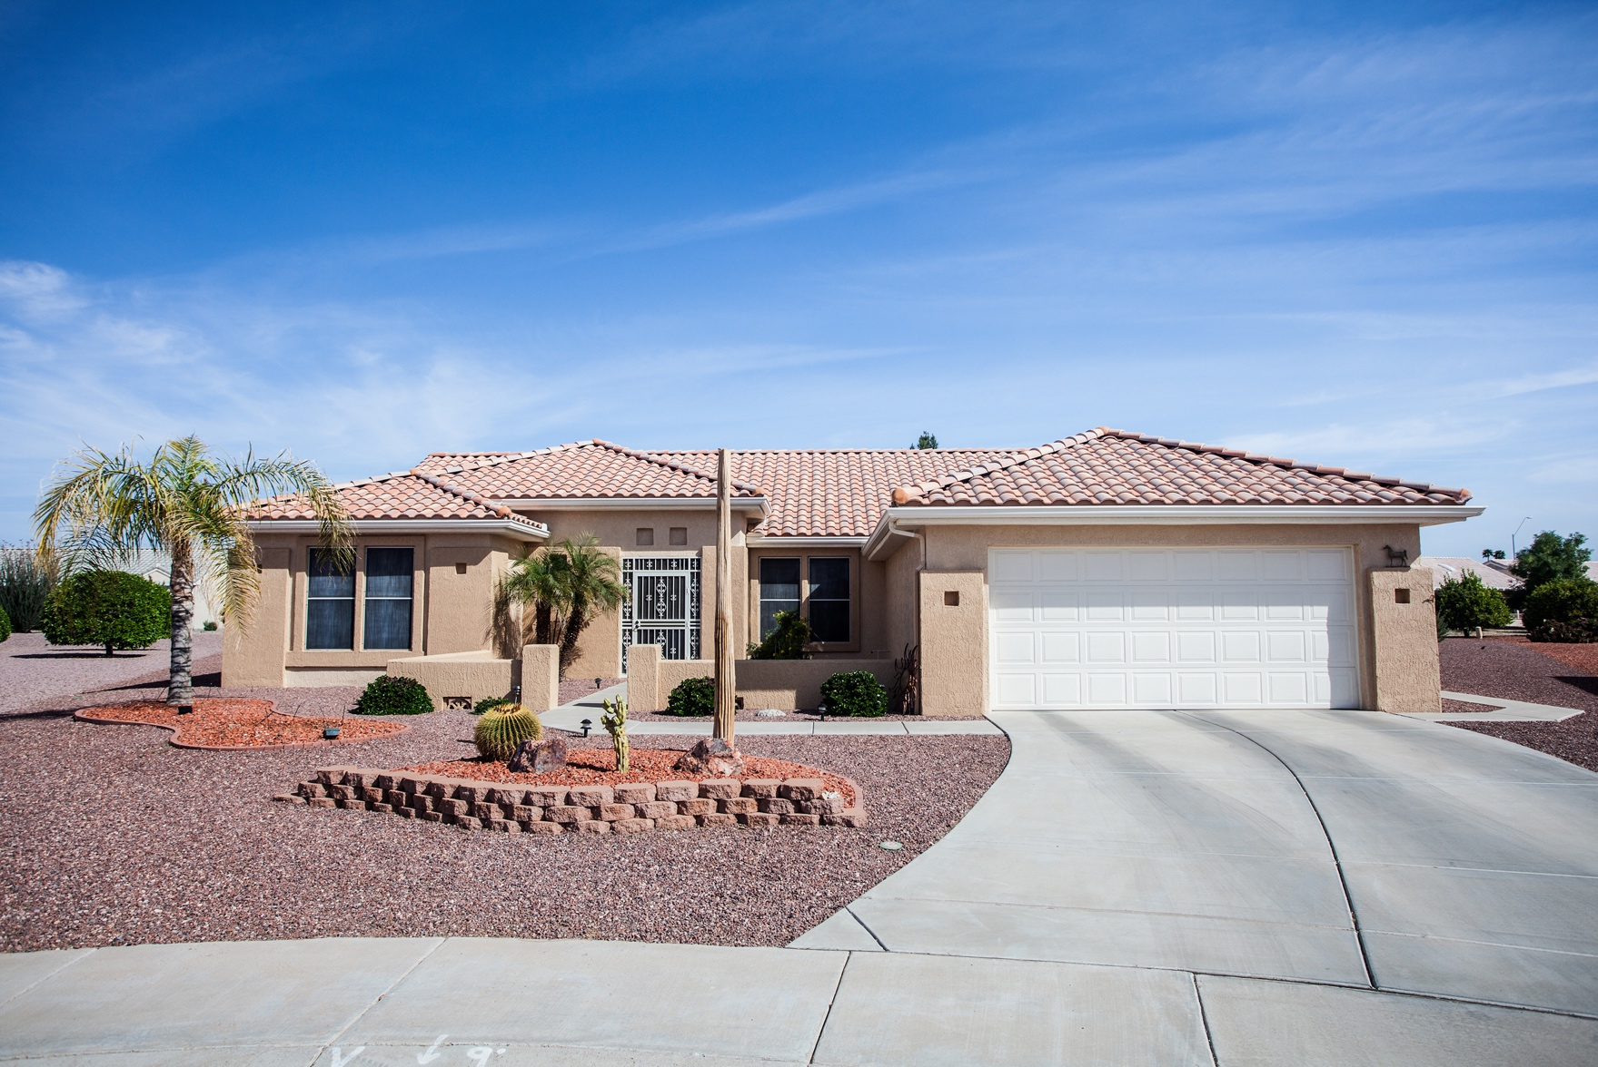

Apply Here!

**Your Financing Options**

123 Main St. City, ST Zip

Monthly Payments As Low As

|  |  |  |
| --- | --- | --- |
| **Terms** | **30-Year Fixed** | **Graduated Payment Mortgage** |
| **Down Payment (%)** |  |  |
| **Loan Amount** |  |  |
| **Rate** |  |  |
| **APR** |  |  |
| **Mortgage Insurance** |  |  |
| **Mortgage Payment** |  |  |
| **Points/Credits** |  |  |
| **Loan Cost** |  |  |
| **Monthly Payment** |  |  |

**$12,345.67**

­­

Plus Taxes & Insurance­­

**This Property at a Glance**

* **Feature 1**
* **Feature 2**
* **Feature 3**
* **Feature 4**

**Listing Price: $400,000**

**Realtor Name**

**

NMLS ID

name@gmail.com

Title

**First Last**

(000)000-0000

name@gmail.com

Title



www.website.com

(000)000-0000

www.website.com

**­­­**

This is only an estimate and not a commitment to lend. Rate displayed is not locked and is subject to change. Unpaid interested on a graduated payment mortgage is added to the principal balance. On adjustable-rate loans, interest rates are subject to potential increases over the life of the loan, once the initial fixed-rate period expires. Rates, loan products & fees subject to change without notice. Your rate and term may vary. If you do not lock in a rate when you apply, your rate at closing may differ from the rate in effect when you applied. Subject to underwriting approval. Not all applicants will be approved, Full documentation & property insurance required. Loan secured by a lien against your property. Consolidating or refinancing debts may increase the time and/or the finance charges/total loan amount needed to repay your debt. Terms, conditions & restrictions apply. Equal Housing Lender